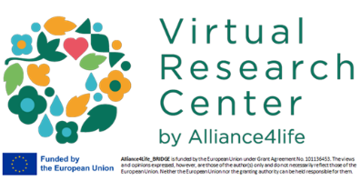
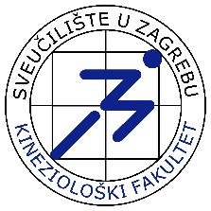
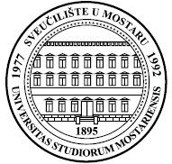
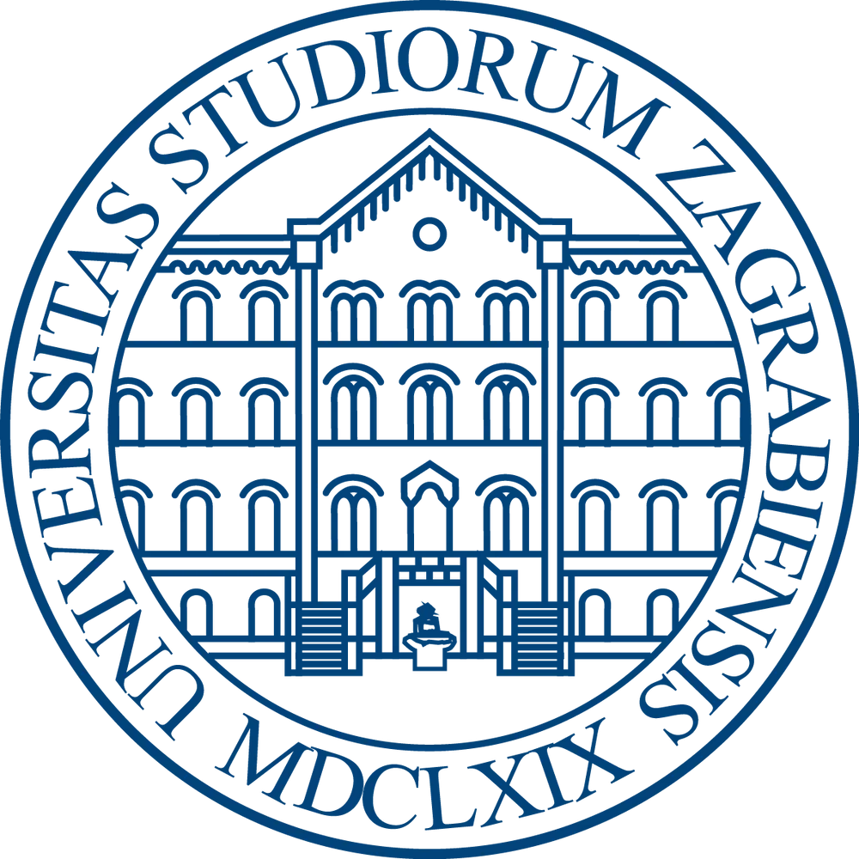
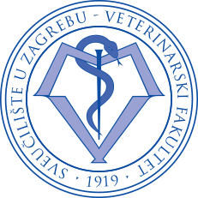
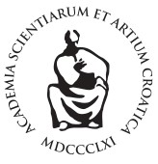
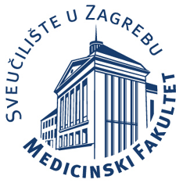
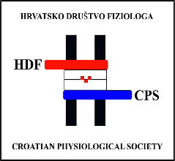
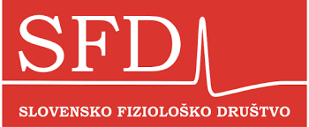
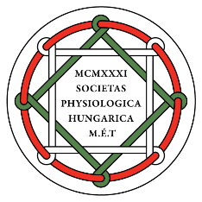
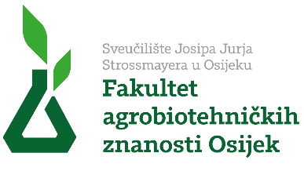
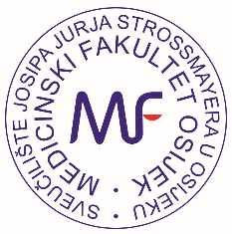

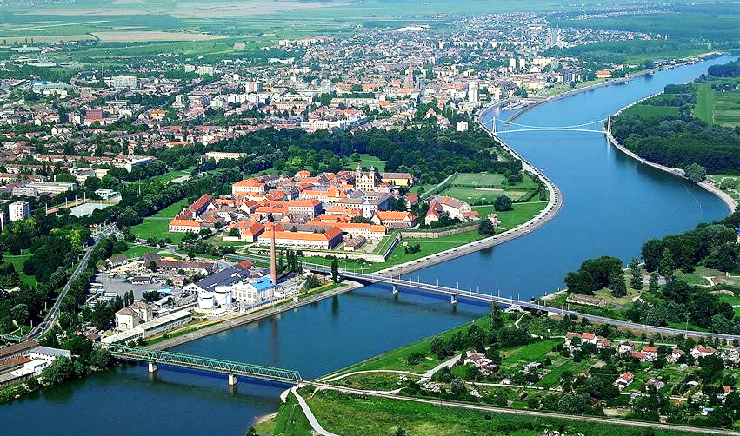

Second Call Congress Programme

October 14 – 16, 2026, Osijek, Croatia

4th Regional Congress of Physiological Societies

and

6th Congress of Croatian Physiological Society

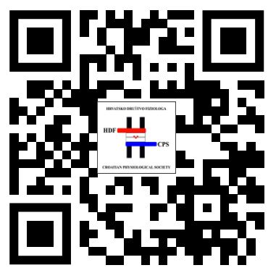

Sponzori i donatori



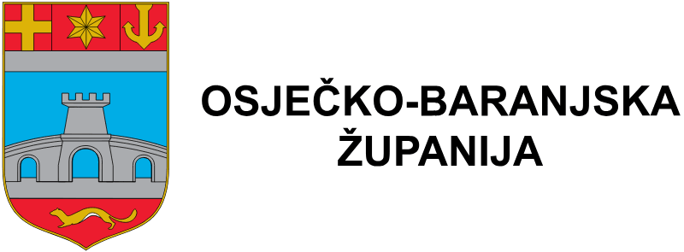







Wednesday, 14 October 2026

11:30 – 12:00 Registration and Welcome Coffee

12:00 – 12:30 Opening Ceremony
Welcome addresses

SESSION 1 — KEYNOTE & IMMUNOPHYSIOLOGY
Chairpersons: Ines Mrakovčić Šutić (Rijeka, Croatia), Ivan Ćavar (Mostar, Bosnia and Herzegovina)

12:30 – 13:15 KEYNOTE LECTURE (35 min + 10 min discussion)

Bojan Polić (University of Rijeka, Rijeka, Croatia)
The role of IFNg in systemic body adaptations to acute viral infections

13:15 – 13:35 INVITED LECTURE (15 + 5)

Dora Višnjić (University of Zagreb School of Medicine, Zagreb, Croatia)
From Metabolic Stress to Cell Cycle Arrest and Differentiation

13:35 – 13:55 INVITED LECTURE (15 + 5)
Ivan Ćavar (University of Mostar School of Medicine, Mostar, Bosnia and Herzegovina)
Serum concentrations of cytokines and PSA in patients with prostate adenocarcinoma

13:55 - 14:05 ORAL COMMUNICATION (8 + 2)
From selected abstracts

14:05 – 14:30 (25 min)
Coffee Break & Poster Session I

SESSION 2 — NEUROSCIENCE AND CEREBRAL PHYSIOLOGY
Chairpersons: Robert Zorec (University of Ljubljana, Slovenia), Marija Renić (Zagreb, Croatia)

14:30 – 14:50 INVITED LECTURE (15 + 5)

Marija Renić (University of Zagreb School of Medicine, Zagreb, Croatia)
Physiology of Cerebral Blood Flow

14:50 – 15:10 INVITED LECTURE (15 + 5)
Robert Zorec (Slovenian Physiological Society, University of Ljubljana, Ljubljana, Slovenia)
Adrenergic Regulation of Astrocytes in Health and Disease

15:10 – 15:30 INVITED LECTURE (15 + 5)
Nina Vardjan (Slovenian Physiological Society, University of Ljubljana, Ljubljana, Slovenia)
Lipid Droplets and Signalling in Astrocyte Stress Response
15:30-15:40 ORAL COMMUNICATION (8 + 2)
Vedrana Karan Rakić (University of Novi Sad, Novi Sad, Serbia)
Title TBA

15:40 – 15:50 ORAL COMMUNICATION (8 + 2)
Anemari Horvat (Slovenian Physiological Society, University of Ljubljana, Slovenia)
Elevated K⁺ Triggers Glycolytic Lactate Mobilisation Contributing to Astrocyte Swelling

15:50 – 16:00 ORAL COMMUNICATION (8 + 2)
Antonio Markotić (University of Mostar School of Medicine, Mostar, Bosnia and Herzegovina)
Effects of "Prime Energy" drink on cognitive and psychomotor functions

SESSION 3: ION CHANNELS AND DISEASE

Chairpersons: Toth Isztvan Balasz (Institute of Physiology, Medical School, University of Pécs, Pécs, Hungary), Hrvoje Lalić (Faculty of Medicine Zagreb University of Zagreb, Croatia)

16:00 - 16:20 INVITED LECTURE (15 + 5)
Balázs István Tóth (Institute of Physiology, University of Pécs Medical School, Pécs; and Department of Physiology, Faculty of Medicine, University of Debrecen, Debrecen, Hungary):

TRP channels in human dental pulp-derived cells and their role in pulpitis

16:20-16:40 INVITED LECTURE (15 + 5)

Aleksandar Kibel (Faculty of Medicine Osijek, Priora International Čepin, Croatia)
The role of SGLT2 inhibitors in the treatment of heart failure

16:40 – 17:00 INVITED LECTURE (15 + 5)
Erika Lisztes (Department of Physiology, Faculty of Medicine, University of Debrecen, Debrecen, Hungary)
Role of TRPV4 in dermal skin regeneration

17:00 - 17:20 INVITED LECTURE (15 + 5)
Viktória Kormos (Department of Pharmacology and Pharmacotherapy, Medical School University of Pécs, Pécs, Hungary)
Examination of Edinger-Westphal nucleus-specific TRPA1 cKO mice in migraine.

17:20 - 17:40 INVITED LECTURE (15 + 5)
Miklós Kecskés (Institute of Physiology, Medical School University of Pécs, Pécs, Hungary) Role of TRPM3 in epilepsy
17:40 - 17:50 ORAL COMMUNICATION (8+2)
Ines Drenjančević (Faculty of Medicine Osijek, University of Osijek, Osijek, Croatia)
High salt diet affects flow-induced dilation via ion channels in Tff3-/-/C57BL/6N knockout and wild-type C57BL/6N mice

19:00 Welcome Reception

Thursday, 15 October 2026

SESSION 4 — VASCULAR PHYSIOLOGY, MICROCIRCULATION & ENDOTHELIAL FUNCTION
Chairpersons: Helena Lenasi (Slovenian Physiological Society, Ljubljana, Slovenia), Ana Stupin (Faculty of Medicine Osijek, Osijek, Croatia)

08:30 – 08:50 INVITED LECTURE (15 + 5)
Akos Koller (Hungarian Physiological Society, Budapest, Hungary)
The molecular mechanisms reflect the different flow-dependent responses of small extra- and intracerebral arteries

08:50 – 09:10 INVITED LECTURE (15 + 5)

Nataša Popović (University of Montenegro, Podgorica, Montenegro)
The Retina as a Window to Systemic Physiology: Translating Physiological Signals into Digital Biomarkers

09:10 – 09:30 INVITED LECTURE (15 + 5)
Zrinka Mihaljević (Faculty of Medicine Osijek, Osijek, Croatia)
Hyperbaric Oxygenation as a Modulator of Endothelial Function: Insights into Redox and Vasodilatory Pathways

09:30 – 09:50 INVITED LECTURE (15 + 5)
Aleksandra Dugandžić (Faculty of Medicine Zagreb, Croatia)
Different roles of brown adipose tissue and brain uroguanylin in males and females

09:50 - 10:10 INVITED LECTURE (15 + 5)
Vladimir Ivančev (Faculty of Medicine University of Split, Croatia)
Physiological health predictors – health as prediction of functionality or functionality as a health predictor

10:10 – 10:45 (35 min)
Coffee Break & Poster Session II

10:45 – 11:05 INVITED LECTURE (15 + 5)
Bari Ferenc (University of Szeged, Szeged, Hungary)
Nimodipine reduces microglial activation as shown by morphological phenotype, phagocytic activity and next generation RNA sequencing

11:05 – 11:25 INVITED LECTURE (15 + 5)

Helena Lenasi (University of Ljubljana, Ljubljana, Slovenia)
Impact of thyroid dysfunction on (micro)vascular and autonomic nervous system (re)activity

11:25 – 11:35 ORAL COMMUNICATION (8 + 2)
Danilo Radunović (University of Montenegro, Podgorica, Montenegro)
Molecular basis of pulse wave velocity (PWV) and its clinical significance

11:35 – 11:45 ORAL COMMUNICATION (8 + 2)

Vladimir Prelević (University of Montenegro, Podgorica, Montenegro)
Chronic kidney disease as a model of early vascular ageing

11:45 - 11:55 ORAL COMMUNICATION (8 + 2)
Danijel Pravdić (Faculty of Medicine Mostar, Bosnia and Herzegovina)
The role of mitochondria in cardioprotection

11:55 -12:15 INVITED LECTURE
Filip Sedlić (Faculty of Medicine Zagreb, Virtual Research Centre All4Life)
Human myocardial miRNA expression in heart failure

12:15 – 12:25 ORAL COMMUNICATION (8 + 2)
From selected abstracts

SESSION 5 — AI, BIOMEDICAL SIGNALS & TRANSLATIONAL TECHNOLOGIES
Chairpersons: Igor V. Pantić (Belgrade, Serbia), Mirza Žižak (Zagreb, Croatia)

12:30 – 12:50 INVITED LECTURE (15 + 5)
Mirza Žižak (University of Zagreb School of Medicine, Zagreb, Croatia)
AI-Supported Flipped Classroom approach: Transforming the role of teachers in medical education

12:50 – 13:10 INVITED LECTURE (15 + 5)
Igor V. Pantić (University of Belgrade, Faculty of Medicine Belgrade, Serbia)
A Fractal-Feature Neural Network for Quantitative Analysis of Two-Dimensional Physiological Signals

13:10 – 13:30 INVITED LECTURE (15+5)

Dragan Mirkov (University of Belgrade, Belgrade, Serbia)

Neuromechanics of the Countermovement Jump: From Neural Drive to Take-Off Velocity

13:30 – 13:40 ORAL COMMUNICATION (8 + 2)
Béla Z. Debreczeni (Doctoral School, Semmelweis University and DrD Plastic Surgery Studio Budapest, Hungary)
Microcirculatory and immunohistopathological assessment of the outcomes of different nipple–areola complex reconstructive surgeries

13:40 - 13:50 ORAL COMMUNICATION (8 + 2)
From selected abstracts

13:50 – 14:30 (45 min)
Lunch Break

SESSION 6 – POSTTRAUMATIC STRESS DISORDER: FROM BENCH TO BEDSIDE (session organized by Hungarian Physiological Society)
Chairpersons: Dora Timea Zelena (University of Pecs, Institue of Physiology, Pecs, Hungary) and Nikola Habek (Faculty of Medicine Zagreb, Croatia)

14:30-14:50 INVITED LECTURE (15 + 5)
Dubrovka Švob-Strac (Institute Rudjer Boskovic, Zagreb, Croatia)
Title: The Biology of Trauma: Searching for PTSD Biomarkers

14:50 – 15:10 INVITED LECTURE (15 + 5)
Dóra Zelena (University of Pécs, Institute of Physiology, Pécs, Hungary)
Title: Metabolic consideration of PTSD

15:10 – 15:30 INVITED LECTURE (15 + 5)
Ana Havelka Meštrović (Algebra Bernays University, Zagreb, Croatia)
Title: Psychophysiological studies in combat PTSD

15:30-15:50 INVITED LECTURE (15 + 5)
Viktória Kormos (University of Pécs, Department of Pharmacology and Pharmacotherapy, Pécs, Hungary)
Title: Transient receptor potential ankyrin 1 ion channels may control the stress adaptation and fear conditioning in a mouse model of posttraumatic stress disorder

15:50 - 16:30 Annual meeting of General Assembly of Croatian Physiological Society (members of CPS only)

16:30 Free afternoon (guided sightseeing of Osijek)

19:00 - 23:00 Conference Dinner
(Restaurant Projekt 9, Gornjodravska obala bb, 31000, Osijek)

Friday, 16 October 2026

SESSION 7 — EXPERIMENTAL MODELS, EDUCATION & ETHICS
Chairpersons: Vladijana Crljen (Faculty of Medicine Zagreb, Croatia), Ivana Jukić (Faculty of Medicine Osijek, Croatia)

08:30 – 08:50 INVITED LECTURE (15 + 5)
Mario Ostović (Faculty of Veterinary Medicine, University of Zagreb, Zagreb, Croatia)
Using animals in biomedical research: Welfare issues and alternatives

08:50 – 09:10 INVITED LECTURE (15 + 5)
Ivan Alić (Faculty of Veterinary Medicine, University of Zagreb, Zagreb, Croatia)
In vitro models in biomedical research

09:10 – 09:20 ORAL COMMUNICATION (8 + 2)
Ana Shek Vugrovečki (Faculty of Veterinary Medicine, University of Zagreb, Zagreb, Croatia)
Are Non-Animal Models Effective in Veterinary Education? Insights from Our Teaching Practice

09:20 – 09:30 ORAL COMMUNICATION (8 + 2)

From selected abstracts

09:30 - 09:40 ORAL COMMUNICATION (8 + 2)
Vladijana Crljen (Faculty of Medicine Zagreb, Croatia)
Title TBA

09:40 – 10:25 (45 min)
Coffee Break & Poster Session III

10:25 – 11:10 PLENARY LECTURE (35 + 10)

Janoš Terzić (Faculty of Medicine Split, Croatia)

The role of microbiota and inflammation in urinary bladder cancer

SESSION 8 — CELL PHYSIOLOGY, IMMUNOLOGY & TRANSLATIONAL RESEARCH (part I)
Chairpersons: Ines Drenjančević (Faculty of Medicine Osijek, Croatia), Dora Višnjić (Faculty of Medicine Zagreb, Croatia)

11:10 – 11:30 INVITED LECTURE (15 + 5)
Markus Ritter (Paracelsus Medical University, Salzburg, Austria)
On the manifold functions of the non-gastric H⁺/K⁺-ATPase ATP12A

11:30 – 11:50 INVITED LECTURE (15 + 5)
Aleksandra Popović (University of Novi Sad, Novi Sad, Serbia)
Functional Analysis of Mitochondria in Permeabilized Muscle Fibers, Tissues, and Cultured Cells

11:50 – 12:00 ORAL COMMUNICATION (8 + 2)
Ivo Krešić (University of Mostar School of Medicine, Mostar, Bosnia and Herzegovina)
Monocyte functional heterogeneity in psoriatic arthritis and ankylosing spondylitis

12:00 – 12:10 ORAL COMMUNICATION (8 + 2)
Pavao Planinić (University of Mostar School of Medicine, Mostar, Bosnia and Herzegovina)
Bone biology in murine models of cholestatic liver injury

SESSION 8 — CELL PHYSIOLOGY, IMMUNOLOGY & TRANSLATIONAL RESEARCH (part II)
Chairpersons: Ines Mrakovčić Šutić (Faculty of Medicine Rijeka, Croatia), Dora Višnjić (Faculty of Medicine Zagreb, Croatia)

12:20 – 12:30 INVITED LECTURE (15 + 5)
Jovana Paunović Pantić (University of Belgrade, Faculty of Medicine Belgrade, Serbia)
Recent Advances in Laser-Based Technologies for Tissue Regeneration

12:30 - 12:50 INVITED LECTURE (15 + 5)

Vlatka Sotošek (University of Rijeka, Rijeka, Croatia)
Endothelial glycocalyx in health and disease

12:50 – 13:10 INVITED LECTURE (15 + 5)

Ana Ugrinska (Medical Faculty, University " Ss Cyril and Methodius" Skopje

Republic of North Macedonia)

The Role of Monounsaturated Fatty Acids on Body Composition, Metabolic Health & Weight Management

13:10 – 13:30 INVITED LECTURE (15 + 5)

Helena Haque Chowdhury (Faculty of Medicine University of Ljubljana, Slovenia)

Advanced Therapy Medicinal Products Are Transforming the Future of Medicine: Clinical Outcomes and Future Directions of the Cell-Based ATMP aHyc for Prostate Cancer

13:30 – 13:50 INVITED LECTURE (15 + 5)

Andraž Stožer (Faculty of Medicine University of Maribor, Slovenia)

From spikes to strikes:

Calcium oscillations in beta cells and their changes during development of type 2 diabetes

13:50 – 14:30 (50 min)
Lunch Break

SESSION 9 - FROM IMMUNOBIOLOGY OF PSORIASIS TO CLINICAL DISEASE CONTROL: IL-23 BLOCKADE WITH RISANOKIZUMAB AND THE POTENTIAL OF DIETARY INTERVENTIONS

14:30 - 16:00
Chairpersons: Melita Vukšić Polić (Faculty of Medicine Osijek, Clinical Hospital Centre Osijek, Croatia), Martina Mihalj (Faculty of Medicine Osijek, Clinical Hospital Centre Osijek, Croatia)

SPEAKERS:
- Ivana Krajina
- Vera Plužarić
- Stana Tokić
(3 × 20 min lectures + panel discussion)

16:00
Closing Remarks and Awards

Venue:

Faculty of Agrobiotechnical Sciences Osijek, University J. J. Strossmayer Osijek, Vladimira Preloga 1, 31000, Osijek

Contact:
Congress organization board (prof. dr. sc. Ines Drenjančević), info@hdf.hr

Registration and Abstract Submission:

Please use Registration Form https://hdf.hr/assets/HDF-2026-form%20FINAL.docx The deadline for abstract submission is September 15th 2026. Abstracts should be sent as doc. or docx. files to the following e-mail address: info@hdf.hr

Accomodation

Osijek offers several hotels and a large number of privately owned accommodation options, which the participants can find through online booking sites. Please take into account that during October Osijek receives a large number of visitors, so make sure to book your accommodation on time.

Hotel Osijek https://www.hotelosijek.hr/home
Hotel Waldinger https://waldinger.hr/
Hotel Silver https://www.hotel-silver.hr/
Maximilian Osijek https://maksimilian.hr/
Merlon https://merlon.hr/?lang=hr
ZOO hotel https://zoo-hotel.hr/
Hotel Materra https://hotelmaterra.com/ (Čepin)

Further information regarding the final program, accommodation, poster size and orientation etc. will be posted on our web site (www.hdf.hr) in the near future. We thank you for your interest in attending this Congress and hope to see you soon! Should you have any further questions, do not hesitate to contact us.

Looking forward to see you in Osijek!

Best regards,

Organization team and Professor Ines Drenjančević, MD, PhD, President of the Croatian Physiological Society

